**SELECT p.`patient_id`,p.`patient_name`,dp.`doc_id` from doctors_patients dp INNER join patient p on dp.patient_id=p.patient_id;**



**SELECT p.`patient_id`,p.`patient_name`,dp.`doc_id`,d.`Doctor_Name` FROM doctors_patients dp,patient p,doctors d WHERE dp.patient_id=p.patient_id AND dp.`doc_id`=d.`doc_id`;**

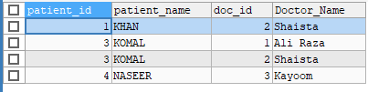

**SELECT * from doctors_patients dp natural join doctors d;**

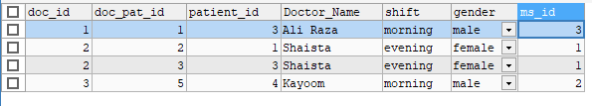

**SELECT * FROM doctors_patients dp LEFT JOIN doctors d ON dp.`doc_id`=d.`doc_id`;**



**SELECT * FROM doctors_patients dp RIGHT JOIN doctors d ON dp.`doc_id`=d.`doc_id`;**

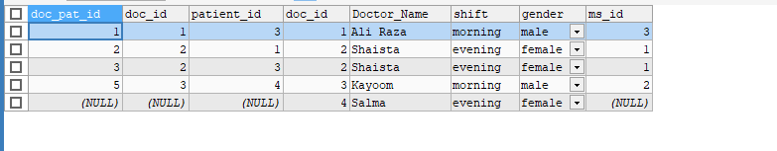

**SELECT * from doctors_patients dp cross join Patient p on dp.`patient_id`=p.`patient_id`;**



**SELECT * from doctors_patients join patient p using(patient_id);**

